1. What is software? What is software engineering?
   * Software is a collection of programs and data that tell a computer how to perform a specific task. Software often includes associated software documentation.
   * The majority of software is written in high-level programming language. They are easier and more efficient for programmers because they are closer to natural languages than machine language.
   * Software Engineering is an engineering-based approach to software development. A software engineer is a person who applies the engineering design process to design, develop, test, maintain and evaluate computer software.
2. Explain types of software.
   * System Software – System software refers to the low-level software that manages and controls a computer’s hardware and provides basic services to higher-level software. Some examples can be operating systems, antivirus software, disk formatting software, computer language translators, etc.
   * Application Software – Application Software is a computer program designed to carry out a specific task other than one relating to the operation of the computer itself, typically used by the end-users. Word processers, media players and accounting software are examples.
   * Malware Software – Malware Software is any software intentionally designed to cause disruption to a computer, server, client or computer network, leak private information, gain unauthorized access to information or systems, deprive access to information, or which unknowingly interferes with the user’s computer security and privacy.
   * Device Drivers – It is a type of software that controls particular hardware to the system. Hardware devices that need a driver to connect to a system include displays, sound cards, printers, mouse and hard disks.
3. What is SDLC? Explain each phase of SDLC.
   * Software Development Life Cycle (SDLC) is a structured process that enables the production of high-quality, low-cost software, in the shortest possible production time. Following are some general phases of SDLC:
     1. Planning:
        + The planning phase encompasses all aspects of project and product management. This typically includes resource allocation, capacity planning, project scheduling, cost estimation, and provisioning.
     2. Coding:
        + The coding phase includes system design in an integrated development environment. It also includes static code analysis and code review for multiple types of devices.
     3. Testing:
        + The phase entails the evaluation of the created software. The testing team evaluates the developed product(s) in order to assess whether they meet the requirements specified in the ‘planning’ phase.
     4. Release:
        + The release phase involves the team packaging, managing and deploying releases across different environments.
4. What is DFD? Create a DFD diagram on Flipkart.
   * A data-flow diagram is a way of representing a flow of data through a process or a system (usually an information system). The DFD also provides information about the outputs and inputs of each entity and the process itself.
   * A data flow diagram (DFD) is a graphical or visual representation using a standardized set of symbols and notations to describe a business's operations through data movement.
   * It uses defined symbols like rectangles, circles, and arrows, along with short text labels, to show data inputs, outputs, storage points, and the routes between each destination.
   * Businesses use DFDs to analyze existing systems to see where roadblocks exist and to create new business processes.
   * DFDs highlight the movement of information as well as the sequence of steps or events required to complete a work task. DFDs do not represent details of software logic and have no control flow, decision rules, or loops.
   * DFDs became popular in the 1970s and have maintained their widespread use by being easy to understand.

Figure 1 DFD for E-Commerce Level-0

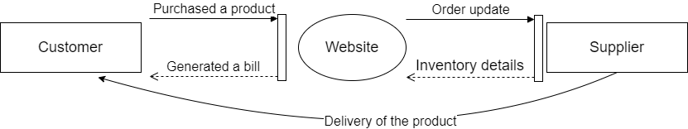

Figure 2 DFD for E-Commerce Level-1

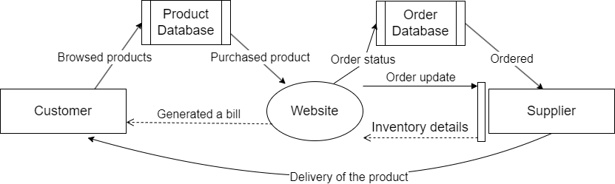

1. What is Flow chart? Create a flowchart to make addition of two numbers.
   * A flowchart is a type of diagram that represents a workflow or process. A flowchart can also be defined as a diagrammatic representation of an algorithm, a step-by-step approach to solving a task.
   * The flowchart shows the steps as boxes of various kinds, and their order by connecting the boxes with arrows.
   * They can range from simple, hand-drawn charts to comprehensive computer-drawn diagrams depicting multiple steps and routes.

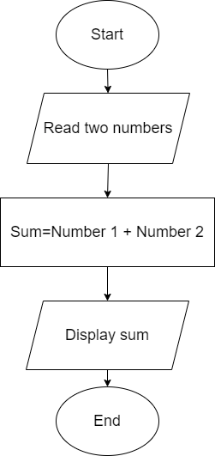

1. What is Use Case Diagram? Create a Use-Case on bill payment on Paytm.
   * A use case diagram is a graphical depiction of a user's possible interactions with a system.
   * A use case diagram shows various use cases and different types of users the system has and will often be accompanied by other types of diagrams as well.
   * The use cases are represented by either circles or ellipses. The actors are often shown as stick figures.
   * The drawings attempt to mimic the real world and provide a view for the stakeholder to understand how the system is going to be designed.

